Ethan Balon [ebb0039]
BCDE211 Best Programming Practices Assessment 3 - Portfolio
campus event planner portfolio

Table of Contents
Starting point from A2 2
Architecture boundary 3
Task 1 evidence – Interactive React + Vite /Next.js Application 4
Display all items in a list or table 4
Code evidence 4
Task 2 Evidence – Add new item using input controls 5
Task 3 Evidence – Provide default values in input controls 9
Task 4 Evidence – Edit/Update existing item 11
Task 5 Evidence – Delete an existing item 13
Task 6 – Discard/Revert edits to an existing item 15
Task 7 Evidence – Validate input and show feedback on invalid input 17
Task 8 Evidence – Sort items in two different ways 19
Task 9 – Search or filter items using at least one criterion 21
Task 10 Evidence – Show one calculation within an item 23
Task 11 Evidence – Show one calculation across multiple items 24
Task 12 Evidence – Demonstrate add, update, load operations using existing persistence pathway 25
Task 13 – Demonstrate one abnormal or failure case and handle it safely 27
Task 2 Evidence – Typed Application Baseline 29
1. React components written in TypeScript 29
2. Interface or type alias 31
3. Functions and handlers with typed parameters 32
PWA Refinement 33
Web app manifest 33
Icons/resources 34
Registered service worker 35
Cached assets/resources 37
Evidence of installable application 37
User facing offline fallback 37

Starting point from A2
After finishing Assessment 2, the backend structure of the Campus Event Planner has already been established with 13 user stories and requirements.
Figure 1 User Stories table from Assessment 2
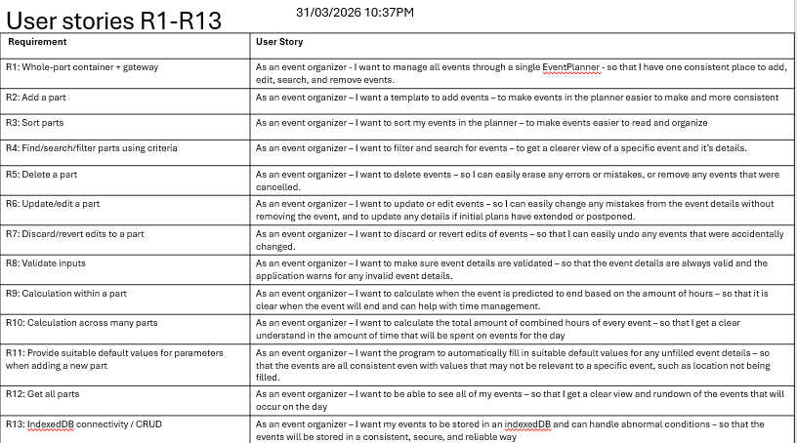
There is already completed source code in the form of Event class, Event Manager class, Event Repository, and IndexedDB. This will be used as the backend which will be built upon on Assessment 3
Figure 2 UML Diagram for Assessment 2 source code
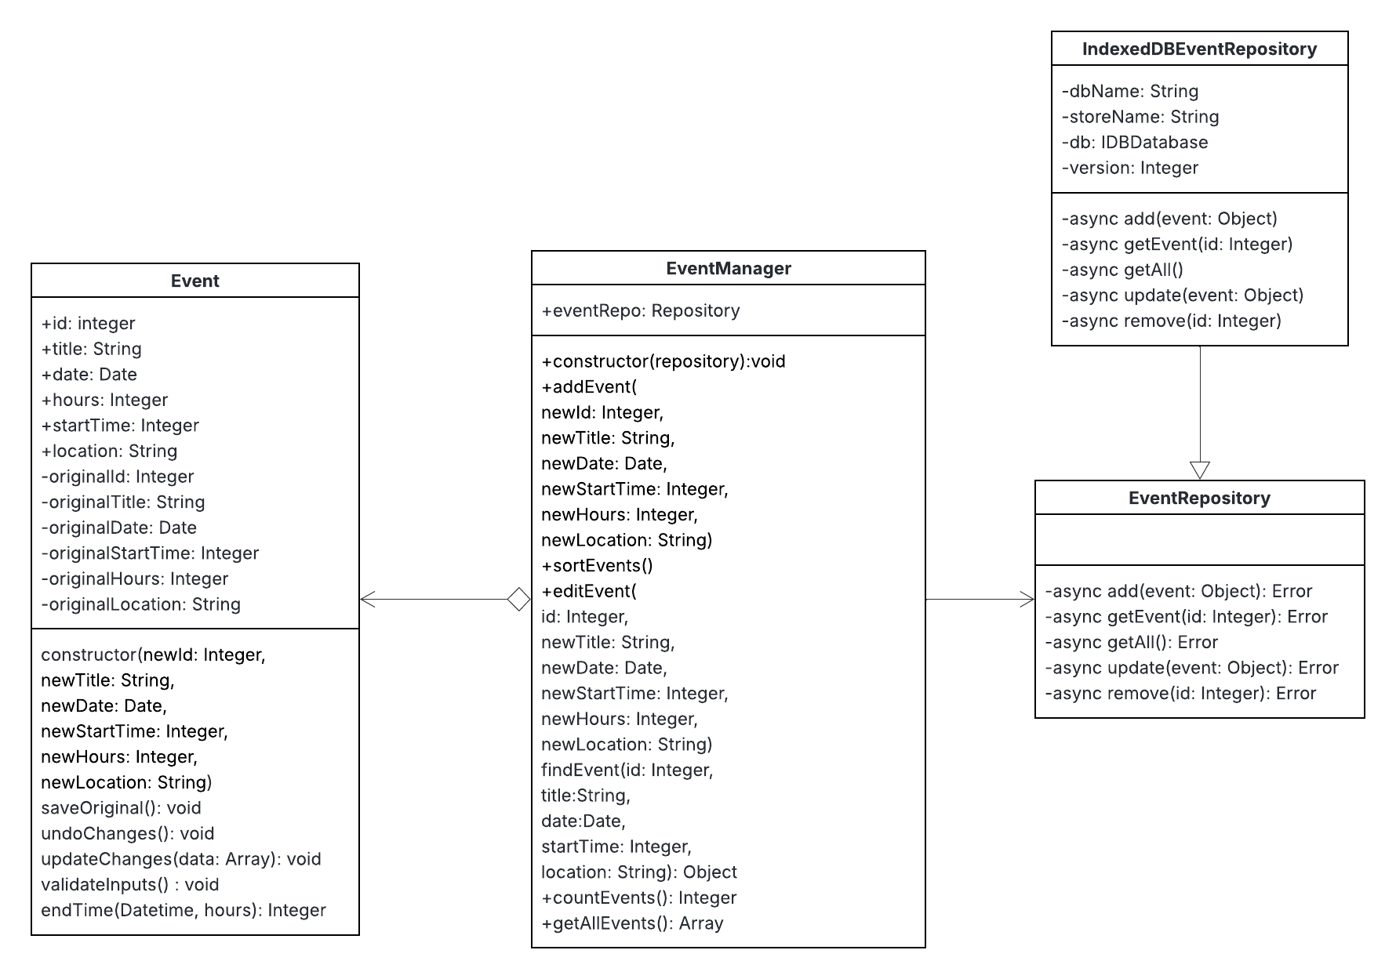

Architecture boundary
For Assessment 3, developing the frontend source code via react + vite, the back end source code from Assessment 2 will continue to be used and will be built upon. React + vite will be integrated with the existing repository. The final structure is as follows in the attached figure.
Figure 3 Code structure including js backend and react + vite frontend
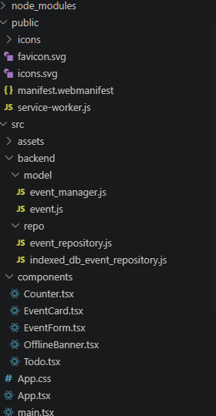

Task 1 evidence – Interactive React + Vite /Next.js Application

Display all items in a list or table
Figure 4 All event items displayed in a CSS grid table
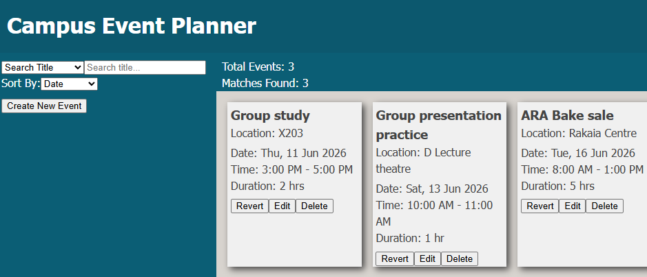
The application is capable of displaying all items in a table, this is done on app.tsx utilizing the length of displayedEvents from getAllEvents() function on backend src, this will add every entry in displayedEvents onto the page in the form of EventCard component, the CSS grid structure will design the text to look like a grid for easy viewing.

Code evidence
Figure 5 Main HTML element featuring table functionality
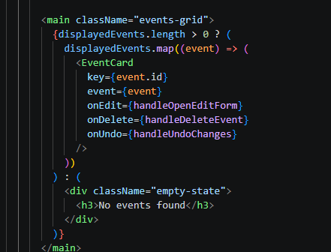
Figure 6 Defining displayedEvents through manager (backend)
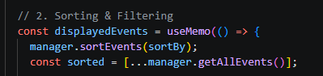
Figure 7 getAllEvents() on event_manager.js from repository
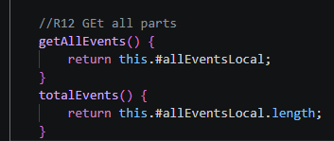

Task 2 Evidence – Add new item using input controls
Figure 8 Form section visible by pressing Create New Event
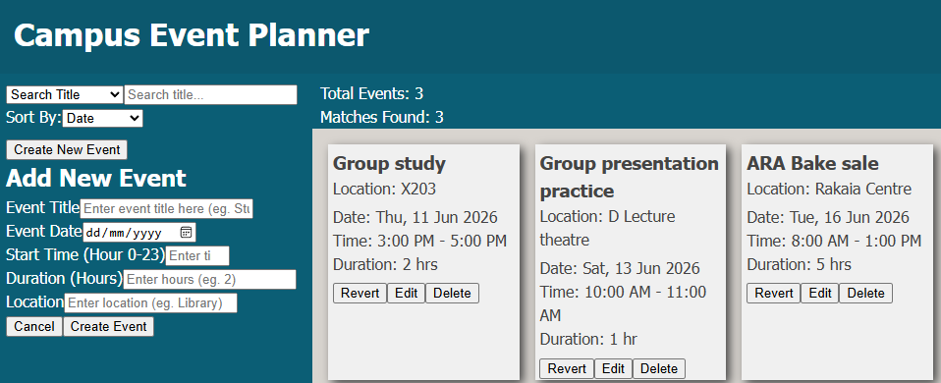
The application is capable of adding a new item using input controls via the eventForm element. Upon clicking Create New Event, app.tsx will insert the eventForm element into the page. Here, this form will accept user input, when the user proceeds to create event, the information is passed onto eventManager where it will be stored in repository.
Figure 9 Small snapshot on eventForm component
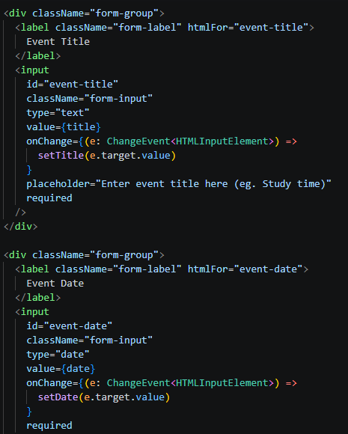
Figure 10 Button element that will trigger saving function
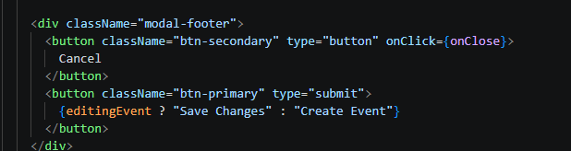
Figure 11 App.tsx Utilizing eventManager to create event
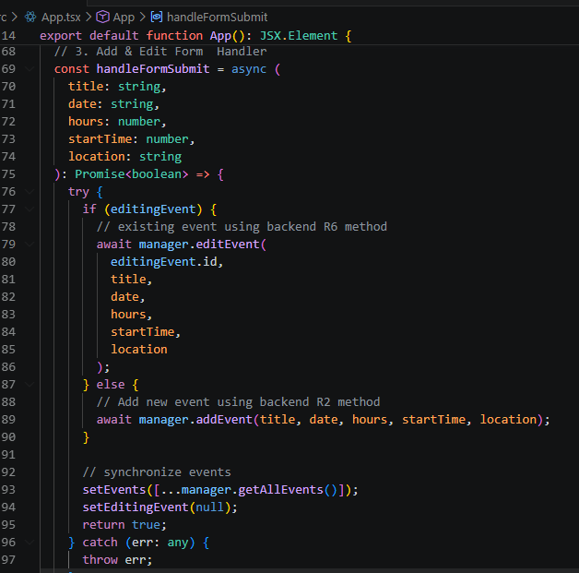
Figure 12 eventManager addEvent() function
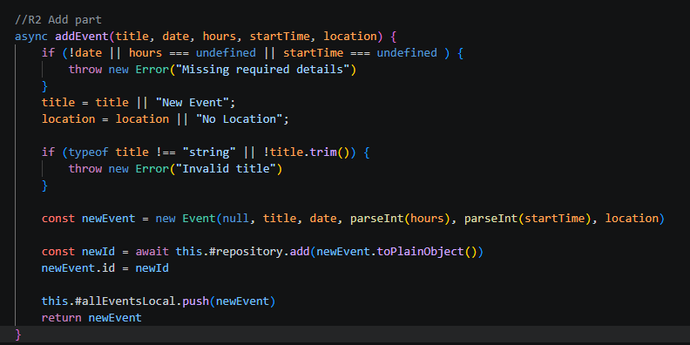

Task 3 Evidence – Provide default values in input controls
Figure 13 eventForm component with default values listed
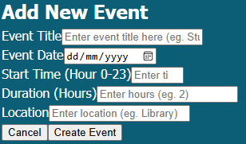
If the user is not editing an existing event, all values are automatically blank by default regardless if another event was previously edited. In addition, placeholder text has been put by default to help the user understand the purpose of each form element.
The application’s backend source code is also capable of providing a default title and location in eventManager, but I have run out of time to integrate these features onto the react + vite front end, however it can be easily added in the future as the backend code already exists.
Figure 14 Snapshot of eventForm input element with placeholder text
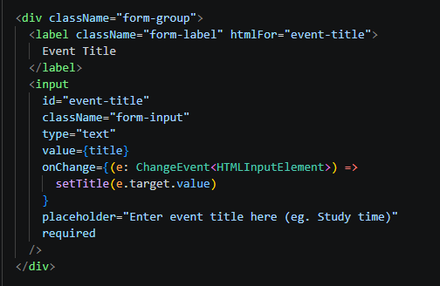
Figure 15 Snapshot of eventForm component if statement, determine when to use default values
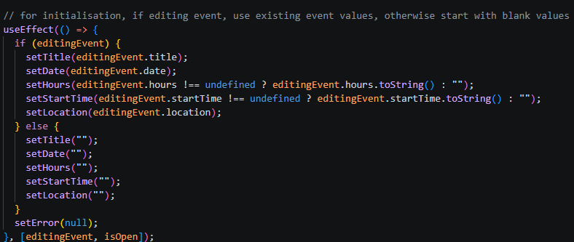
Figure 16 addEvent() function in eventManager, it is capable of providing default title and location values which can be integrated in the future
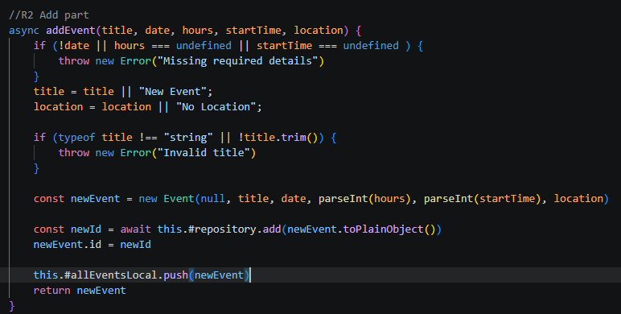

Task 4 Evidence – Edit/Update existing item
Figure 17 eventForm component now in edit mode with values from existing item
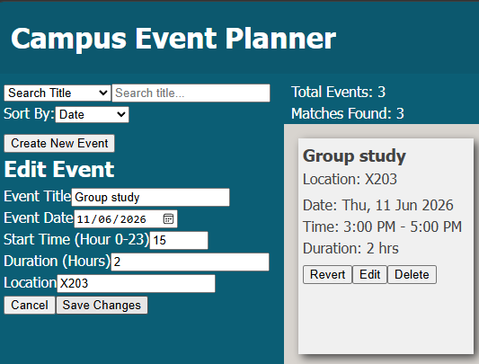
The app is capable of editing an existing item. When the user pressed Edit on an event card, it will trigger edit mode on event form, this will change the title from “Add Event” to “Edit Event”, additionally, it will load the event’s existing values to be edited or updated by the user.
Figure 18 Snapshot of eventForm element function determine when to use edit mode or add mode
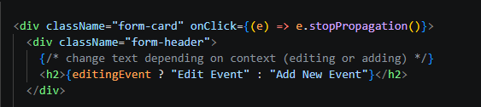
Figure 19 eventForm will load existing value onto page
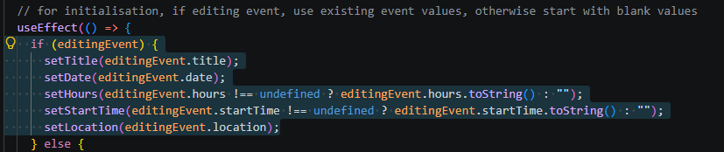
Figure 20 app.tsx utilizing eventManager to edit event
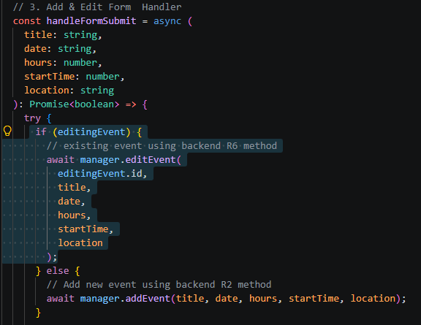
Figure 21 eventManager calling event object to update with new given values
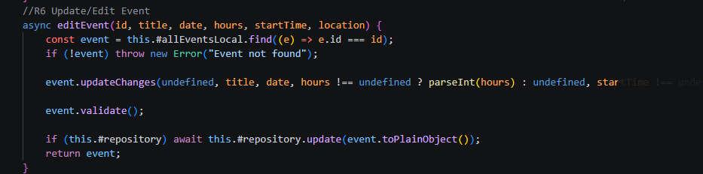
Figure 22 Event object updateChanges() function, will only change given values
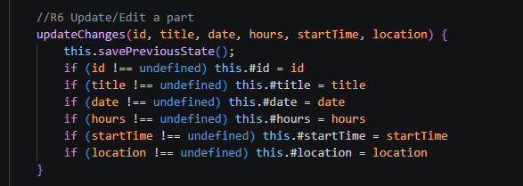

Task 5 Evidence – Delete an existing item
Figure 23 Campus event planner prompting user to confirm delete
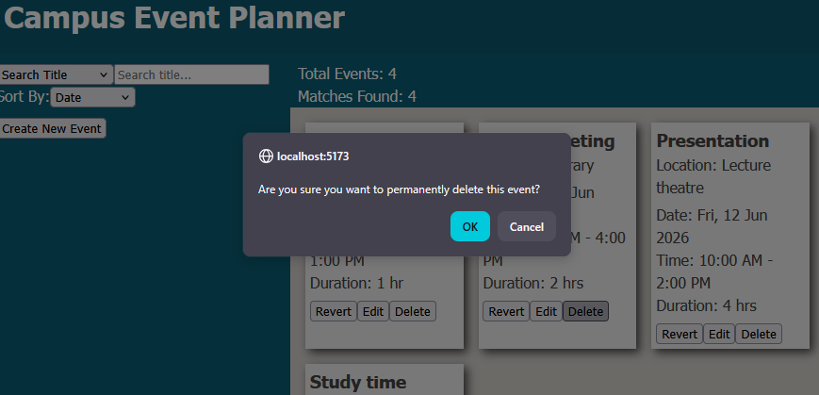
The application can delete an existing item, when the delete button on eventCard component is pressed by the user, it will trigger app.tsx to first prompt the user to confirm deletion, and then use deleteEvent() handler from eventManager.
Figure 24 Snapshot on delete button element in eventCard component
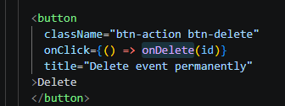
Figure 25 Snapshot of app.tsx deleteEvent handler, will first confirm delete with user and then use deleteEvent() from eventManager
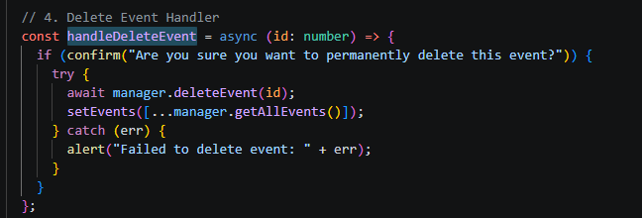
Figure 26 Snapshot of eventManager deleteEvent(), searches for event object first before removing it from repository
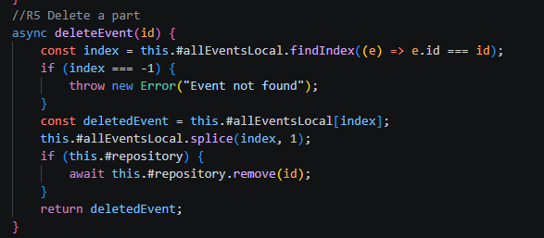

Task 6 – Discard/Revert edits to an existing item
Figure 27 Campus Event Planner prompting user to convert revert
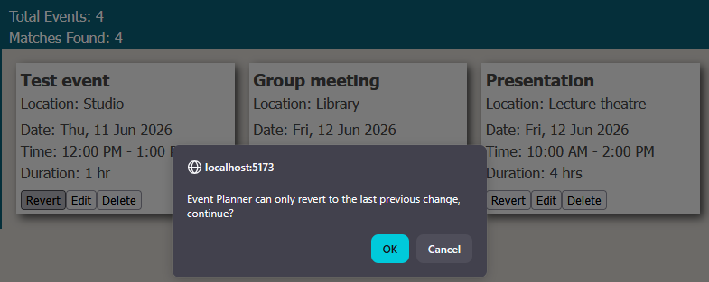
The application can revert the last previous change of an event. When the revert button is clicked on an event card, it will be caught by app.tsx undochanges handler, which will call the undoEvent() function from eventManager, this will inturn call the undoChanges() function from the event object itself where it will use the stored data from the previous change.
Figure 28 Revert button on eventCard component
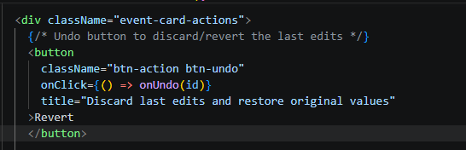
Figure 29 app.tsx first confirming with user to undo, then call undoEvent() from eventManager to handle the undo changes
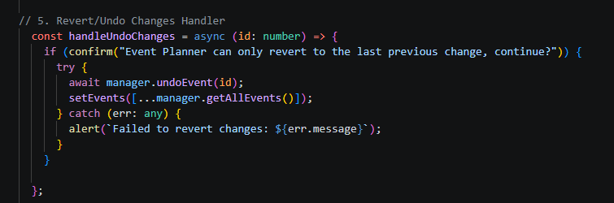
Figure 30 eventManager will then look for the event object, and call it to undo changes
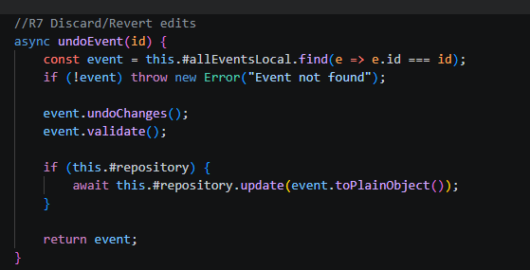
Figure 31 event object overwriting existing values with previous values stored in a seperate array
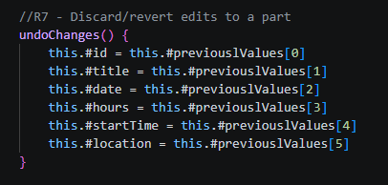

Task 7 Evidence – Validate input and show feedback on invalid input
The Campus Event Planner is able to detect for missing or invalid inputs and inform the user that one of the fields has been incorrectly to handle user error. This is done in the eventForm component
Figure 32 Campus Event Planner alerting user to fill required fields
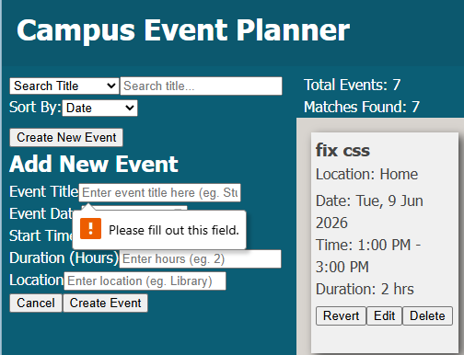
Figure 33 Campus Event Planner alerting user that values are invalid
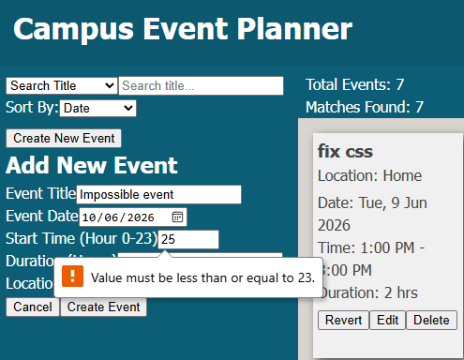

Figure 34 Snapshot of eventForm component with user error checking
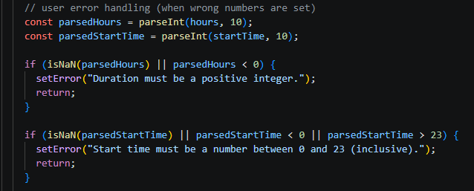

Task 8 Evidence – Sort items in two different ways
Figure 35 Sorting events by title
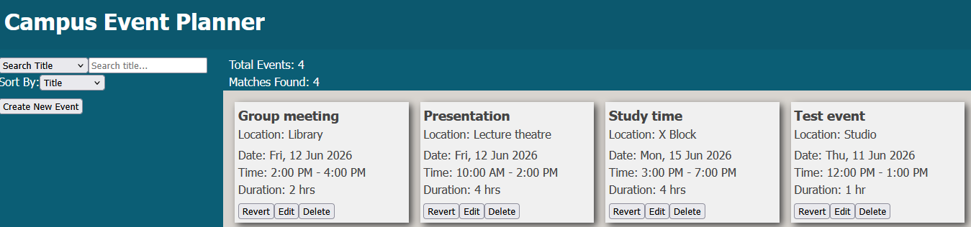
Figure 36 Sorting events by location (location name)
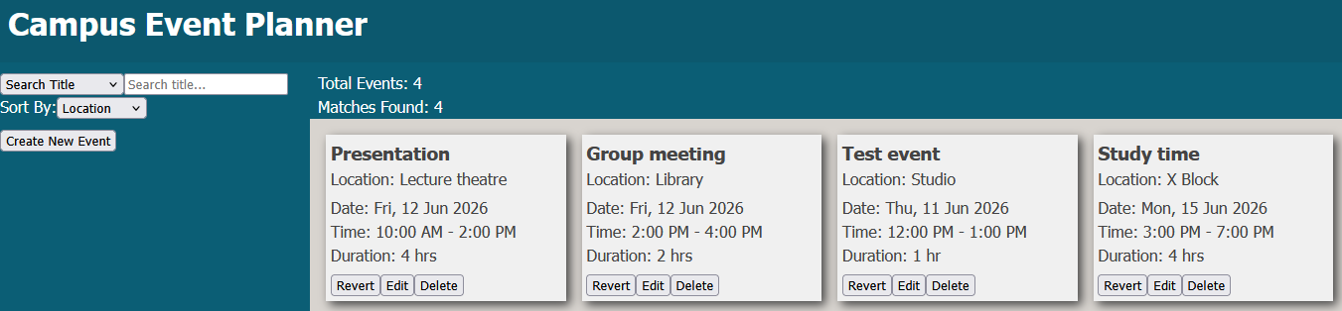
The Campus Event Planner is able to sort items in multiple ways, the events grid can be organized according to date, title, location, duration, and start time. This is handled app.tsx and uses the sortEvents() function from eventManager.
Figure 37 When changed, the sort select element will change the usestate value of setSortBy
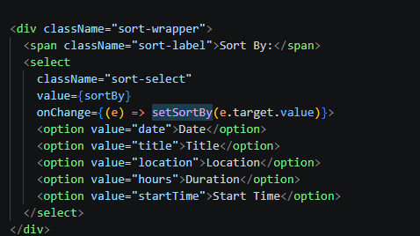
Figure 38 useMemo will be triggered by the changed state and will call sortEvents() located in eventManager
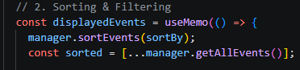
Figure 39 Sort events in eventManager
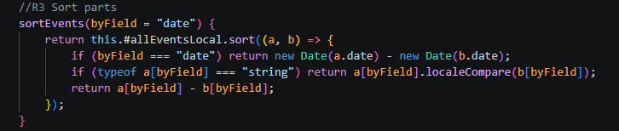

Task 9 – Search or filter items using at least one criterion
Figure 40 Campus Event Planner displaying only events that contain "group" in title
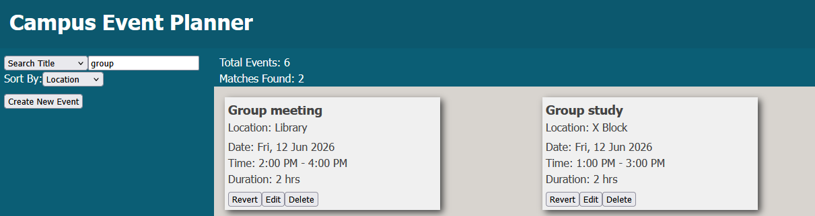
Figure 41 Campus Event Planner only displaying events that contain "library" in the location
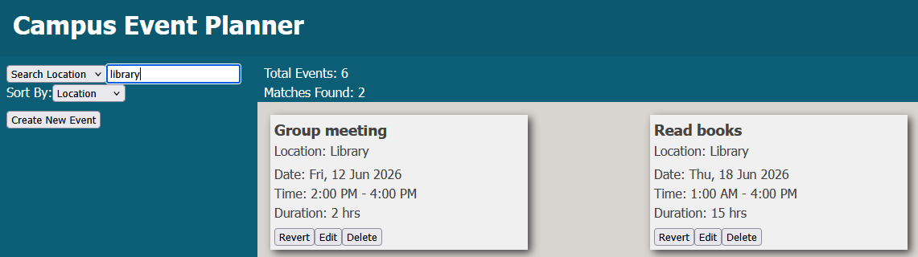
Figure 42 Campus Event Planner only displaying events that occur on 12th June
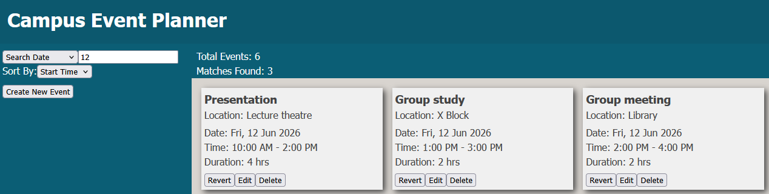
The Campus Event Planner can search or filter items using multiple criterion, this is run entirely on app.tsx. When a search query is entered, the seachquery usestate is changed which triggers usememo, after that the events will be filtered and be returned if it includes the query
Figure 43snapshot of search input element, changes usestate when query is entered
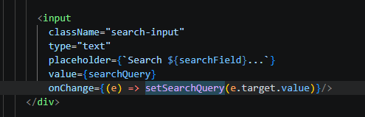
Figure 44 usememo is triggered and events are first sorted, then they will be filtered and returned according to user query
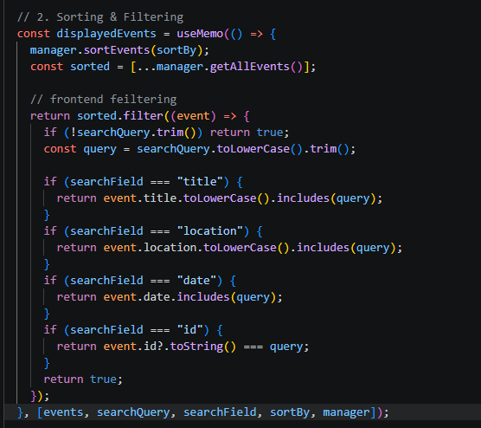

Task 10 Evidence – Show one calculation within an item
Figure 45 Events grid with calculated estimated end time based on duration
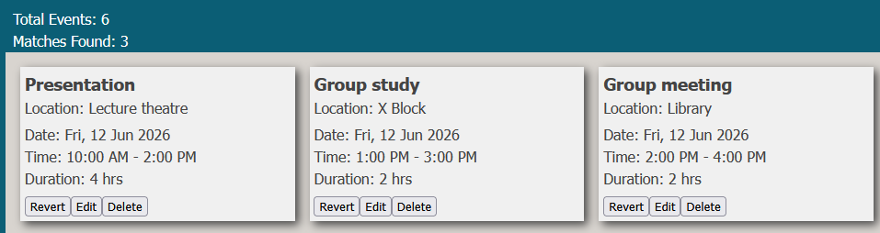
Since end time is not an option in the event form, the Campus Event Planner will predict the end time based on duration. When first adding an event the newly created eventCard component will call the calculateEndTime() function on the event object it is linked to.
Figure 46 Upon creation, eventCard will call calculateEndTime()
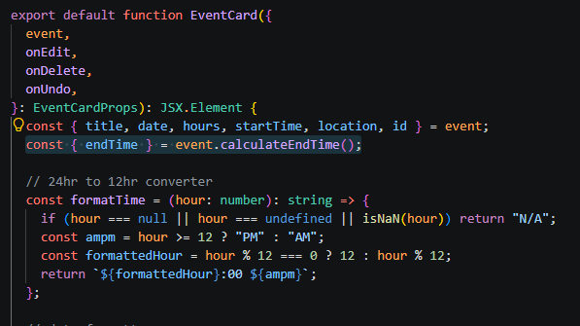
Figure 47 The event object that is tied to the event card will then predict the end time by calculating start time and duration
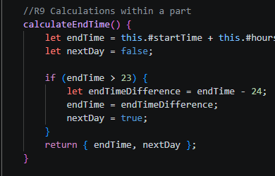

Task 11 Evidence – Show one calculation across multiple items
Figure 48 Campus Event Planner calculating number of events and number of query matches
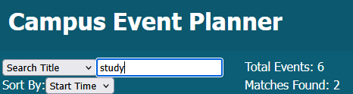
The Campus Event Planner is capable of calculating the number of multiple events saved. This is done by the app.tsx which calculates the length of the events array that stores all of the events objects. In addition, when a search query is presented, the Campus Event Planner can also calculate the total number of events that match the search query. This also works in app.tsx where the length of displayedEvents is calculated instead.
Figure 49 The code of the statsbar section in app.tsx, it reads the length of both the events and displayedEvents array to calculate the total items
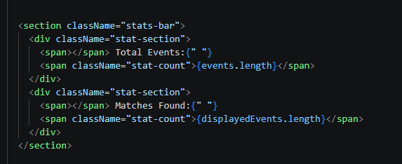

Task 12 Evidence – Demonstrate add, update, load operations using existing persistence pathway
The react + vite frontend portion of Campus Event Planner is heavily integrated with the existing javascript code from Assessment 2. Add and update are functions carried over from eventManager, whilst loading uses the existing indexed DB event repository.
Figure 50 Snapshot of both the existing EventManager and IndexedDbEventRepository being used in app.jsx
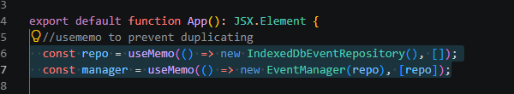
Figure 51 Snapshot of eventManager, unchanged since Assessment 2
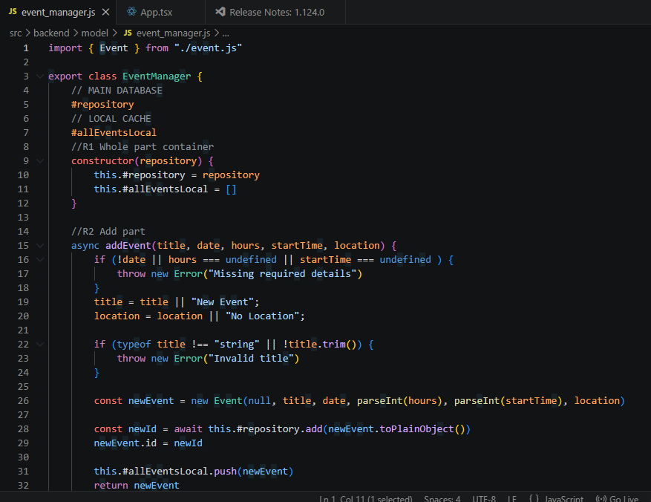
Figure 52 Snapshot of IndexedDbEventRepository, unchanged since Assessment 2
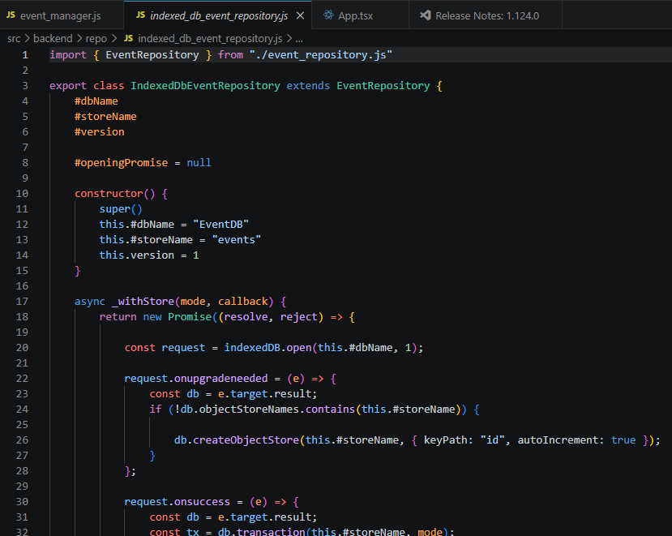

Task 13 – Demonstrate one abnormal or failure case and handle it safely
Figure 53 Campus Event Planner reacting to invalid values, refuse to create event to prevent value errors, and warn user of invalid values
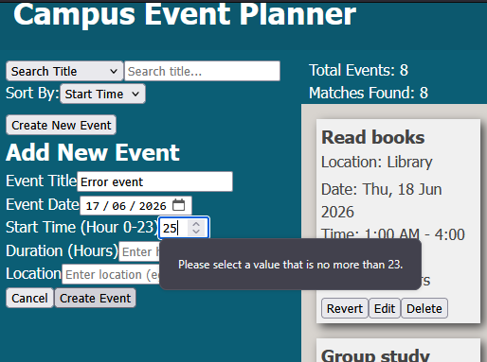
A noticeable example of safe error handling is when the Campus Event Planner refuses to create a new event until all required fields are filled with valid values, this is to prevent errors that may occur. In addition, many functions on the react + vite frontend has the ability to catch errors safely and to alert the user on the error that has been caused.
Figure 54 Snapshot of an example with error handling, function catches error and informs user of the failed deletion
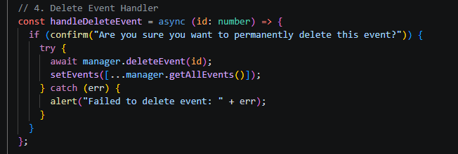
Figure 55 Snapshot on eventForm component, form will display error message when error occurs
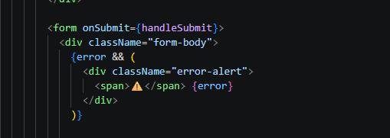
Figure 56 Snapshot of error handling when IndexedDB does not load correctly
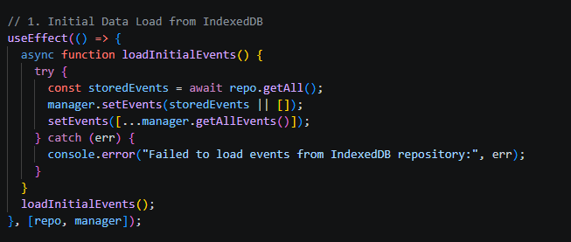

Task 2 Evidence – Typed Application Baseline

React components written in TypeScript
Figure 57 Campus Event Planner components directory
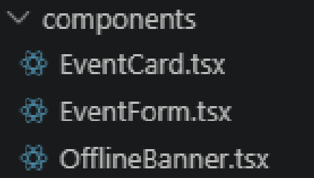
Campus Event Planner contains 3 components, EventCard and EventForm for frontend functionality, and OfflineBanner for fallback when internet connection is not available.
Figure 58 Snapshot of EventCard component
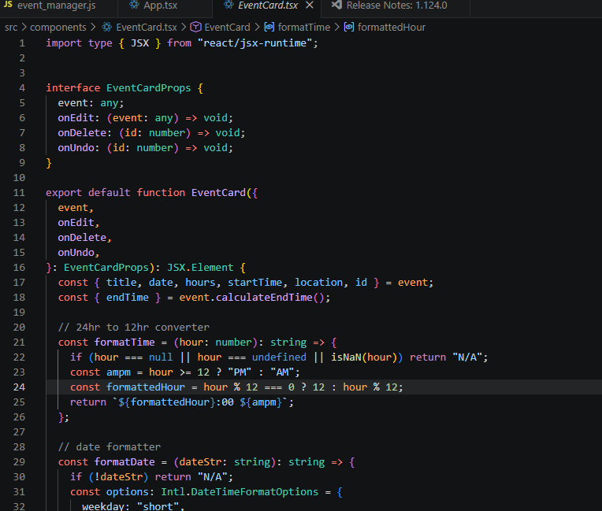
Figure 59 EventForm Component
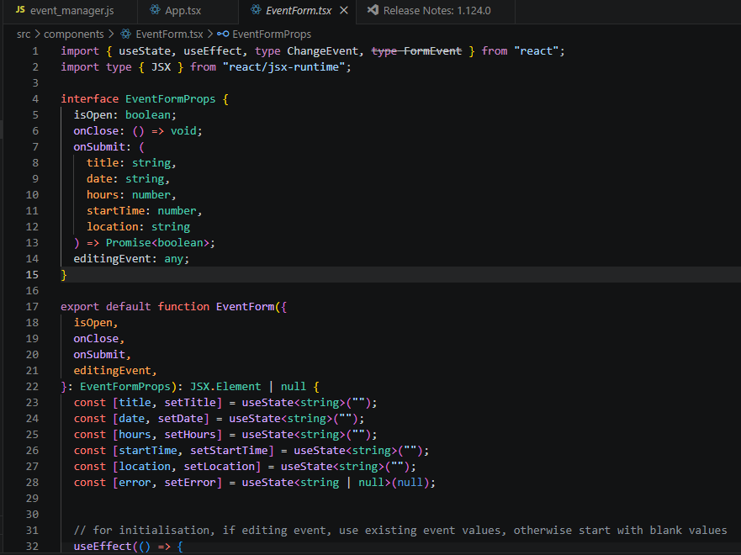
Figure 60 Snapshot of OfflineBanner component
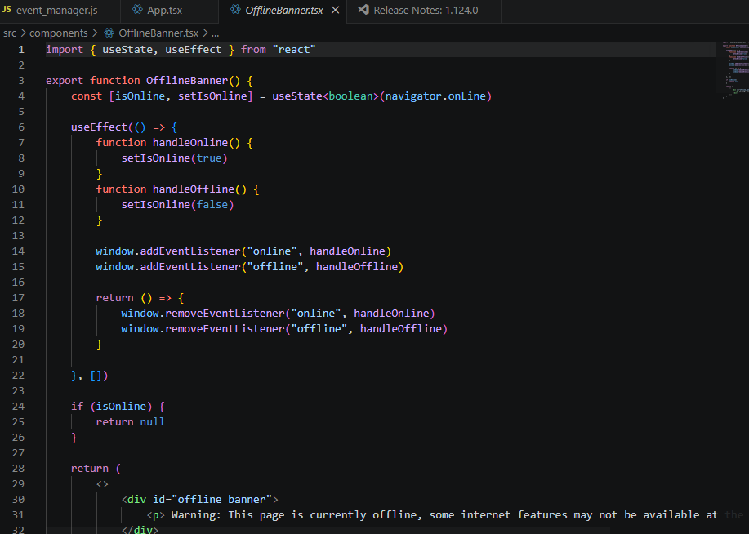

Interface or type alias
In Campus Event Planner, two interfaces were used, eventCard and eventForm, these two interfaces were then used on app.tsx
Figure 61 Snapshot of EventForm interface
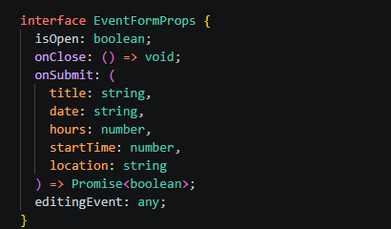
Figure 62 Snapshot of EventCard interface
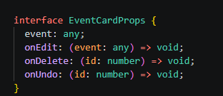
Figure 63 Snapshot of app.tsx using both eventform and eventcard
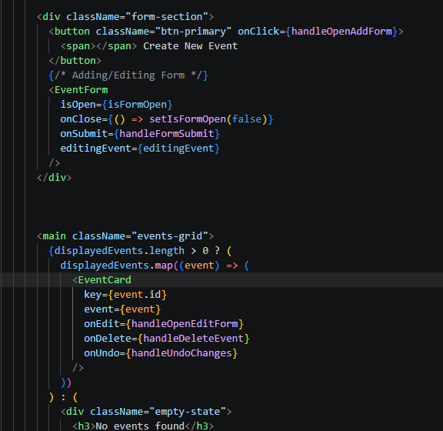

Functions and handlers with typed parameters
Campus Event Planner uses various functions and handlers with typed parameters, a few for example has been presented in the following evidence snapshots.
Figure 64 Snapshot of app.tsx both DeleteEvent and UndoChange handlers use typed parameters and expect a number
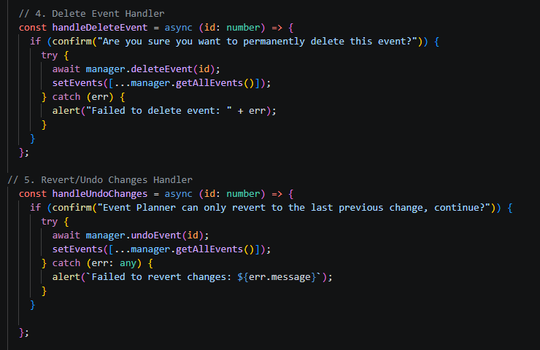
Figure 65 Snapshot of EventCard component, formatTime expects a number, whilst formatDate expects a string
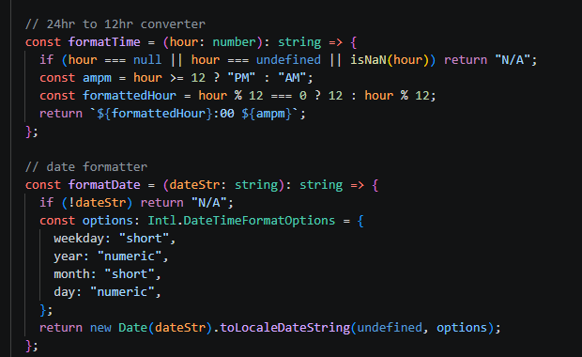

PWA Refinement
Campus Event Planner is designed to be a web application with a PWA structure. Complete with a valid web app manifest, icons, service worker, cached resources, installation capability, and offline fallback.

Web app manifest
Figure 66 Snapshot of working web manifest
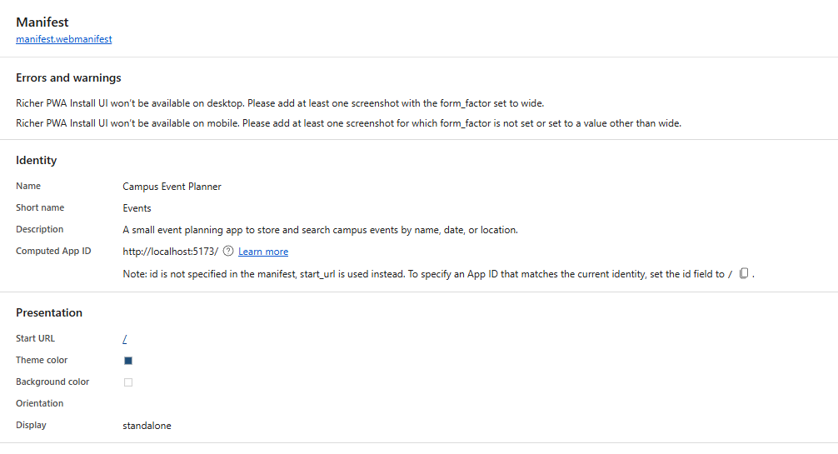
Figure 67 Source code of web manifest
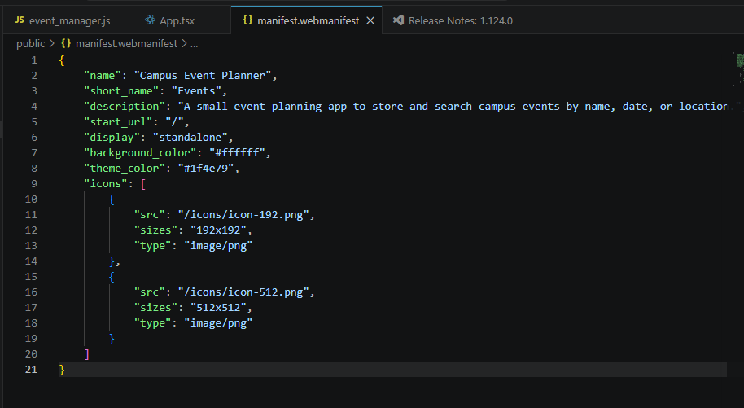

Icons/resources
Two icons were made and used for stability.
Figure 68 Snapshot of Icons directory
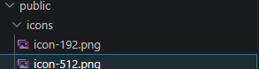
Figure 69 Snapshot of icons detected in the web browser
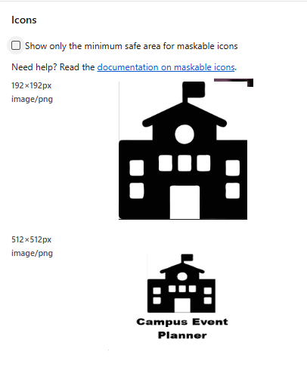

Registered service worker
Figure 70 Service worker detected on web browser
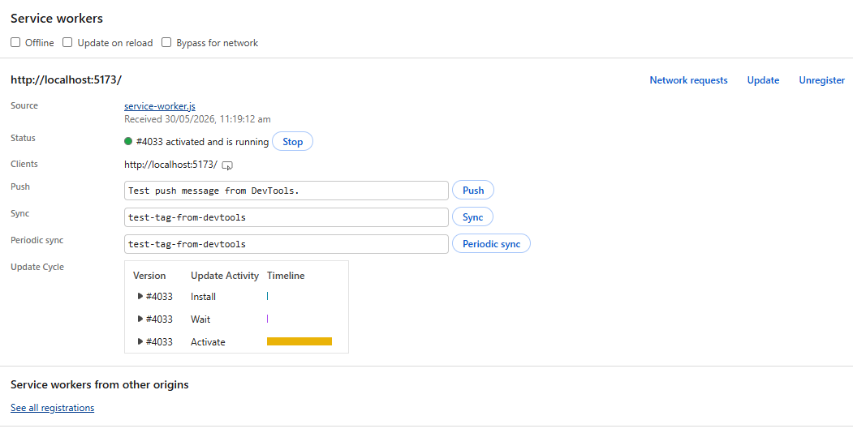
Figure 71 Service worker registering and fetching on console
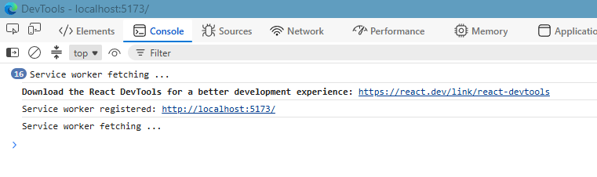
Figure 72 Source code of service worker
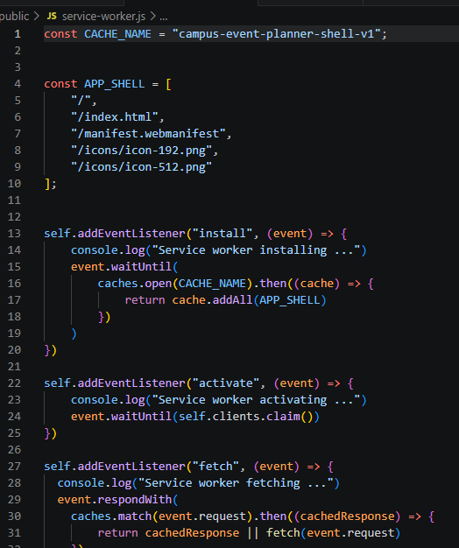

Cached assets/resources
Figure 73 Snapshot of cached storage in web browser
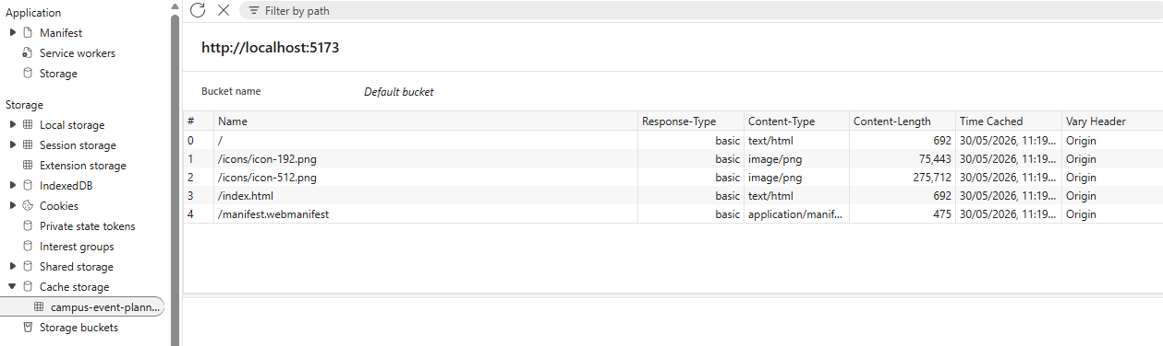

Evidence of installable application
Figure 74 Snapshot of web browser prompting user if they wish to install Campus Event Planner application
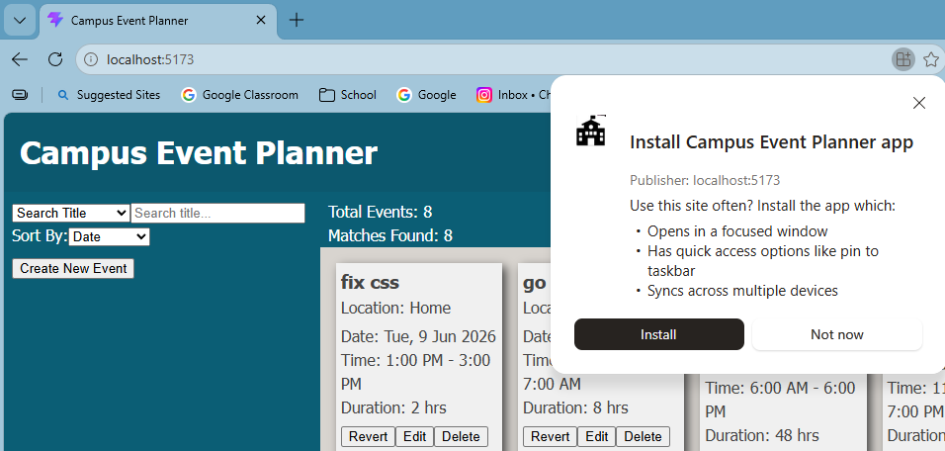

User facing offline fallback
Figure 75 Snapshot of offline warning message being displayed to user when internet is not available
